**Day 6 – Tasks Output**

**// Movie base class**

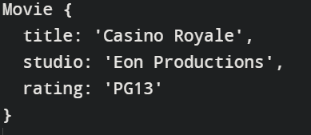

**// Circle base class**

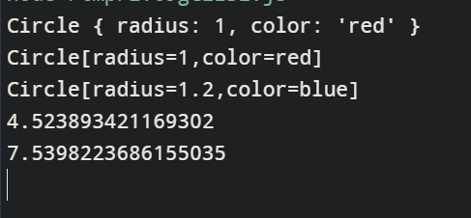

**// Person base class**



**// Uber base class**

